BITEME

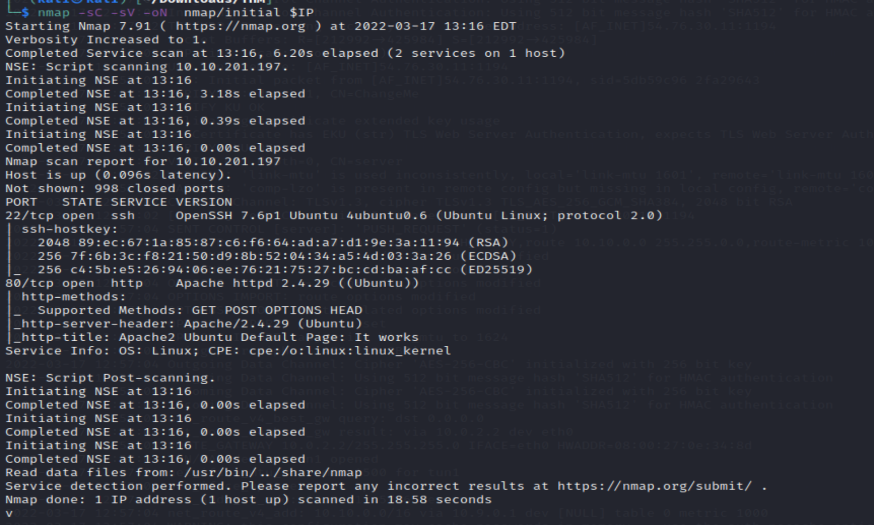

Naturally the next step after inspect code is going for dirb, gobuster but I found a rust based faster alternative feroxbuster.

As per github repo for dir enumeration

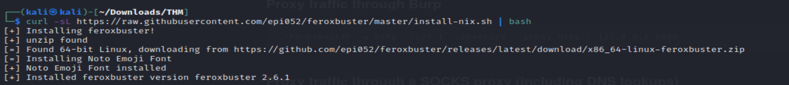

I used cleaner

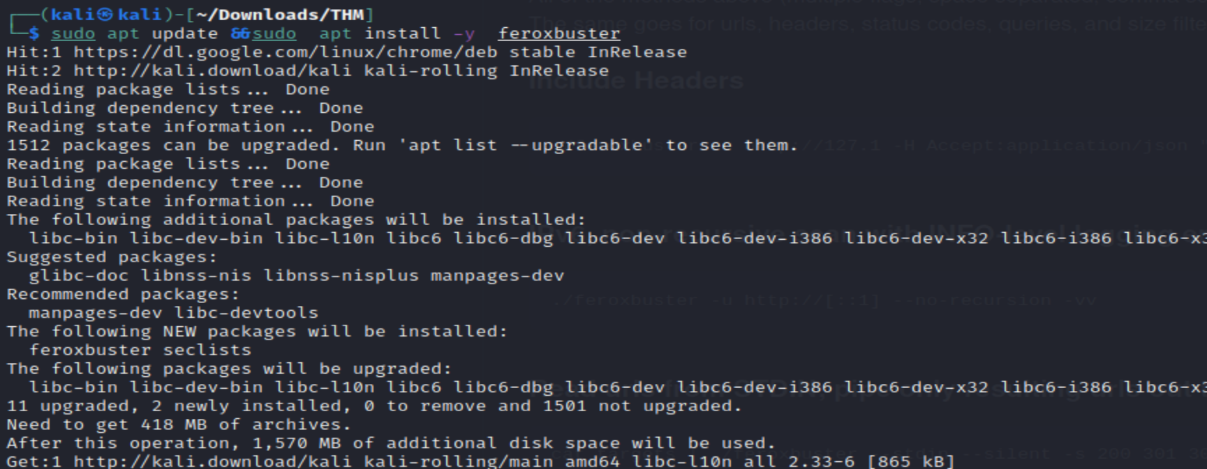

Running it , can see seclist based enum

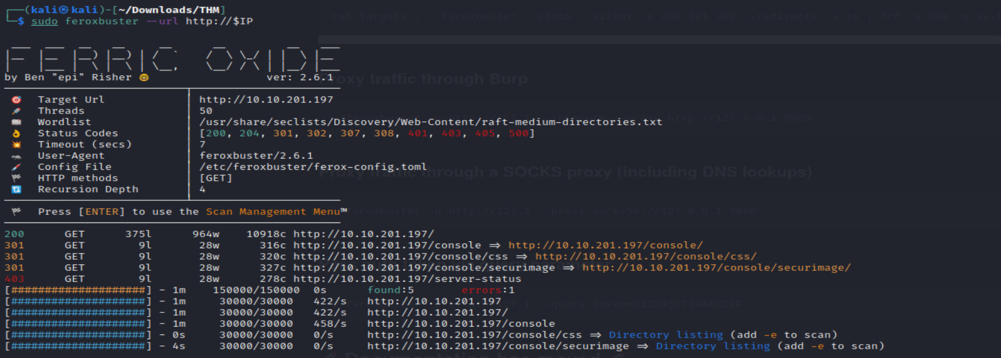

So I focus on secureimage php exploitation as name is intriguing, found some links

Checking out the console , cant get past captcha



Even after js deobsfucation , it not that helpful, it seems

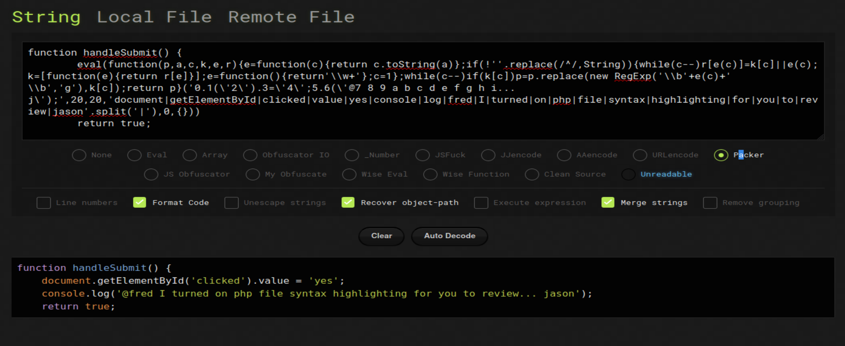

But we can check the header of index.php it show the server , php session cookie. So if php is highlighting , I some case phps can be found show the server side code in case php

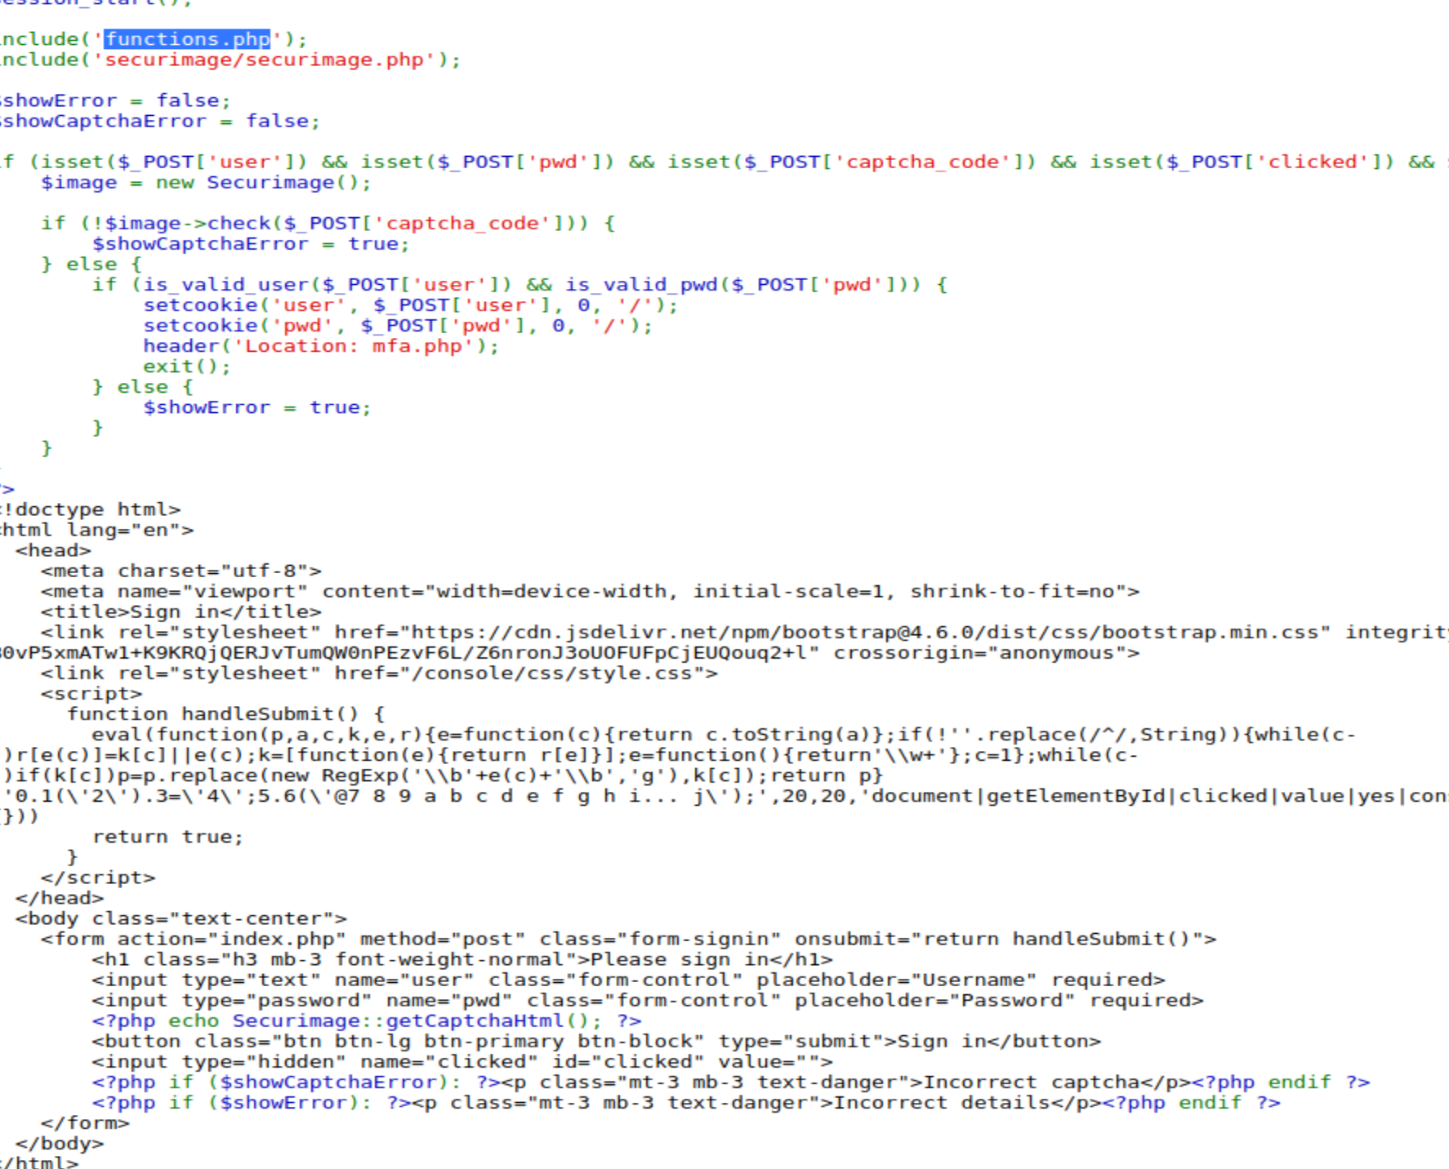

We can see mfa.php and try to navigate but didn’t get any luck as cookie might be need . Atleast know mfa is there some where

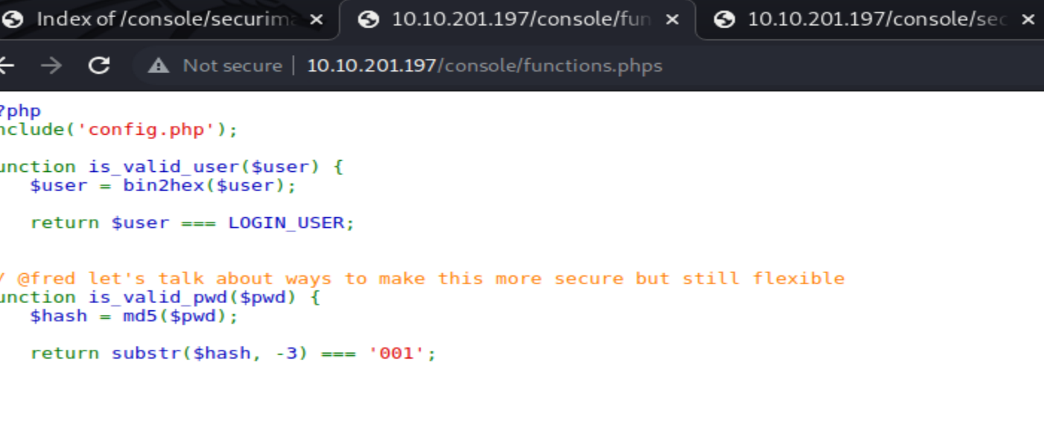

Reading another server side show a hex code for login user let explore that

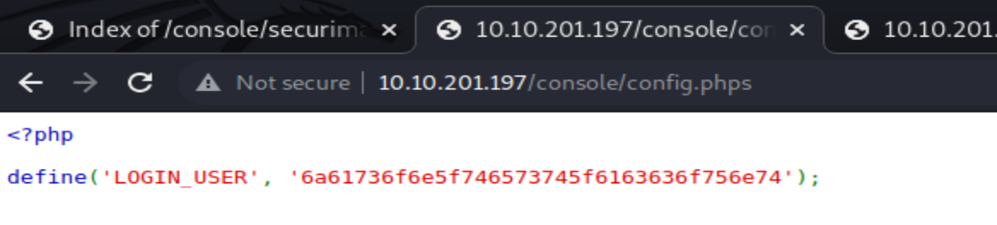

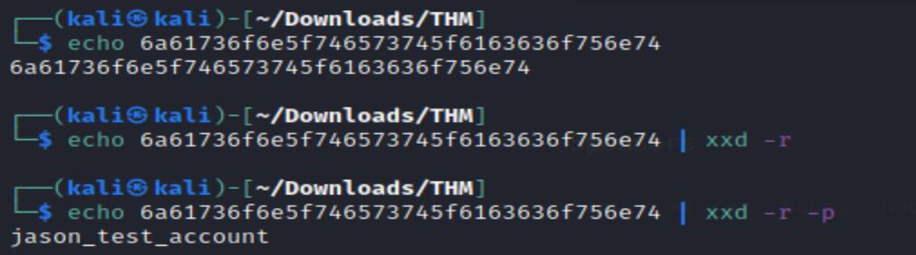

So the function phps also show the hash is check for last 001

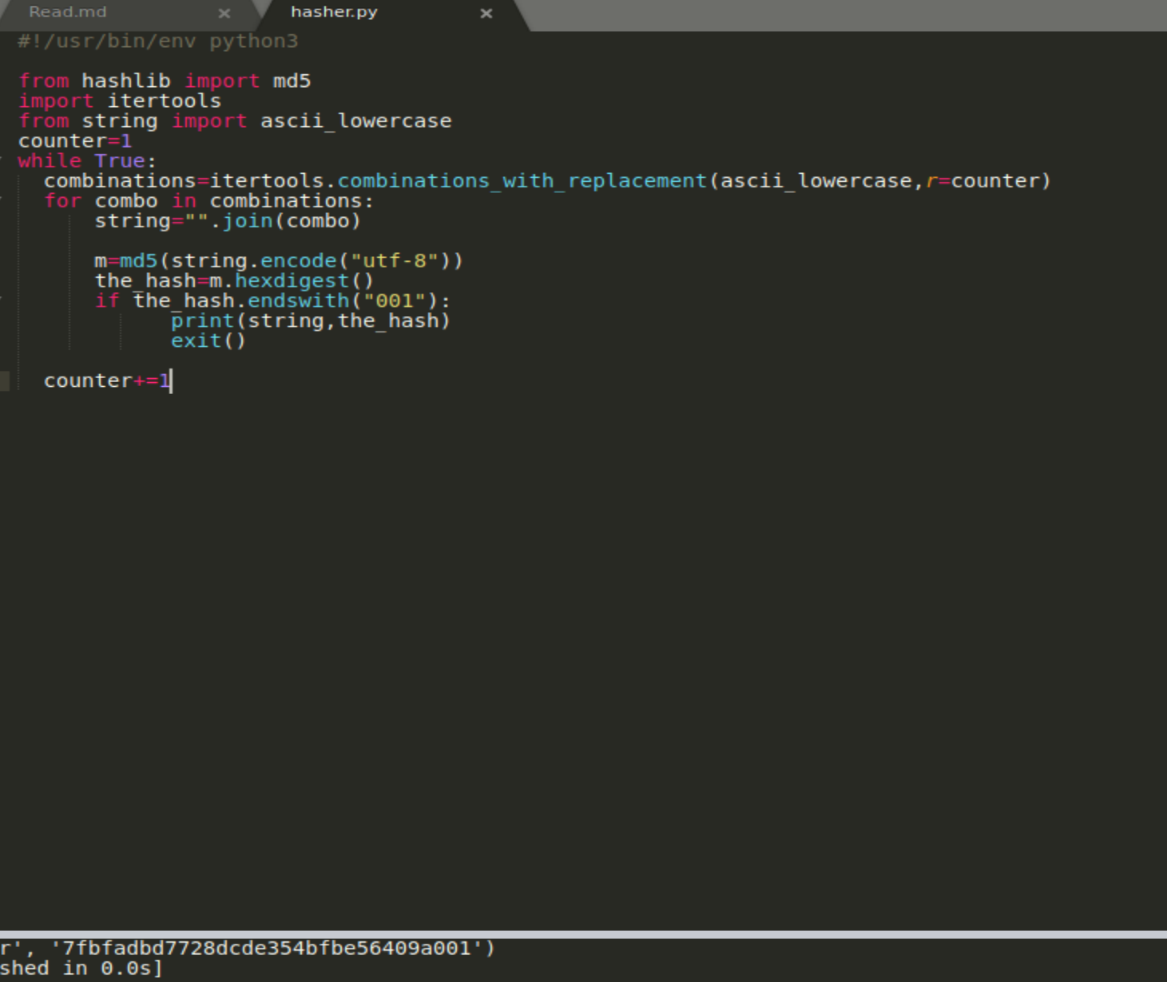

Using the string generated as password with Jason_test_account we can get the cookie and to the MFA page. Now we can bruteforce 4 digit code

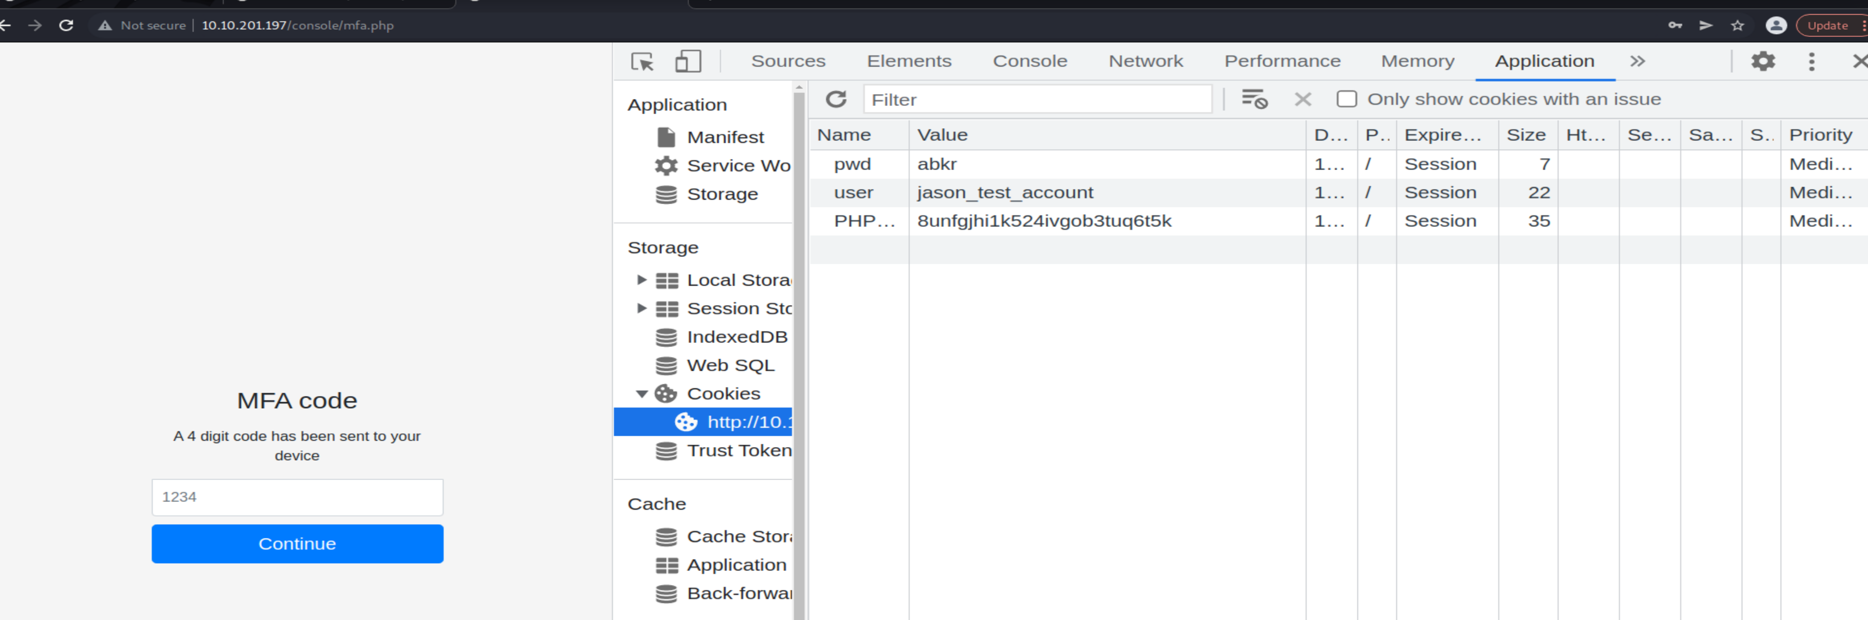

O using below script we can post request with 4digit code ans user credentials , find output when exit is zero(which means everything is ok)

for i in {0000..9999}; do echo $1;curl -s -X POST --data "code=$i" $IP/console/mfa.php --cookie "user=jason_test_account;pwd=abkr"| wc |grep -v " 23 95 1523

"; if [ $? -eq 0 ]; then echo FOUND IT ; break; fi;done

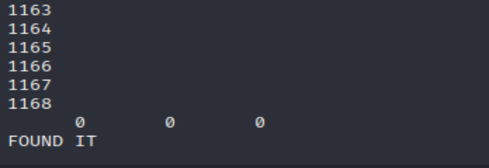

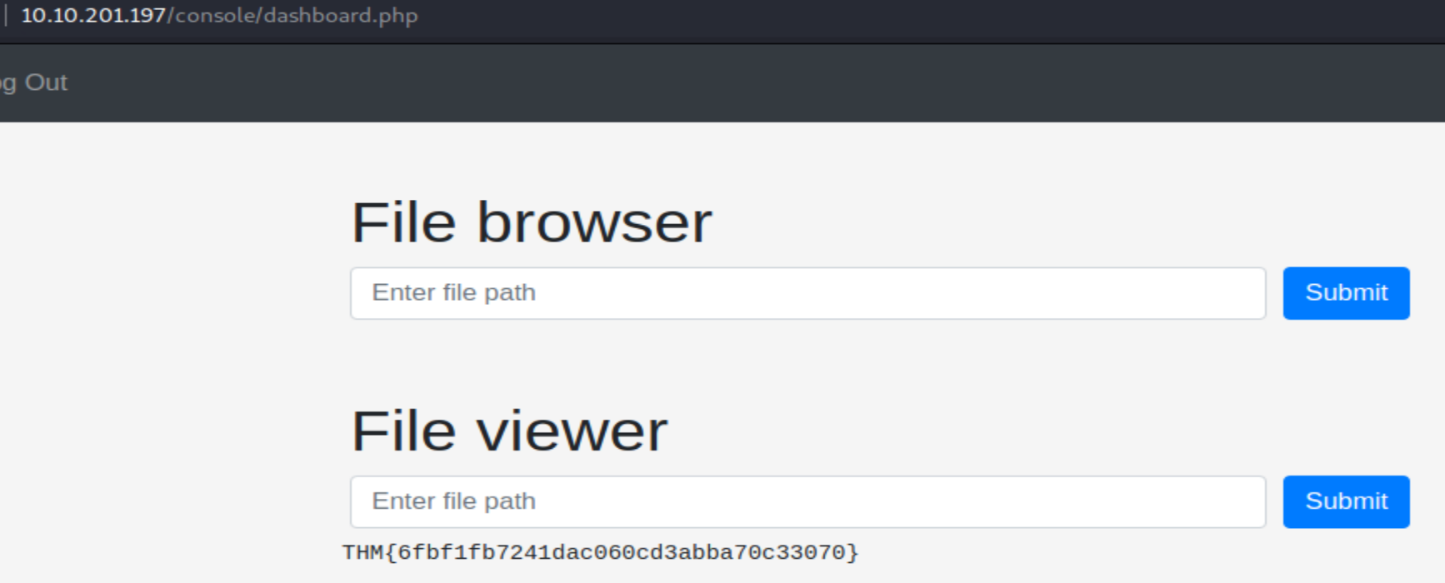

Using simple file viewer , try in .ssh, home dir , we can file the priv key of Jason

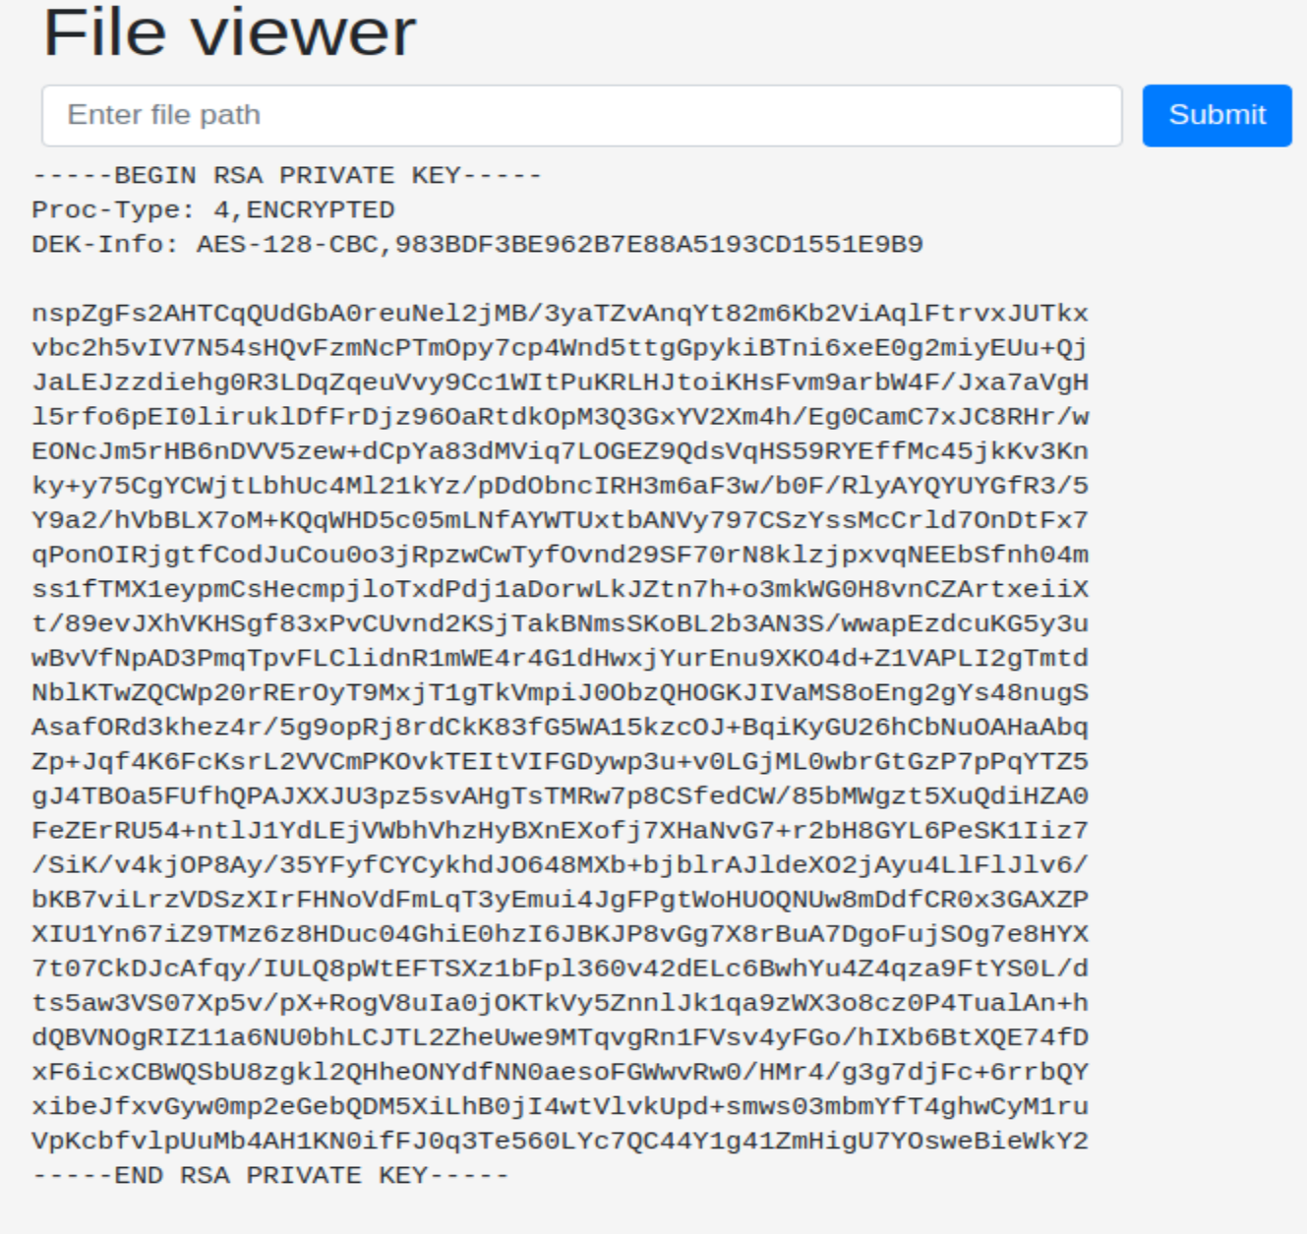

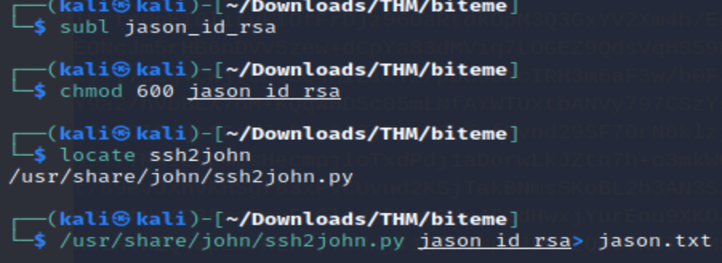

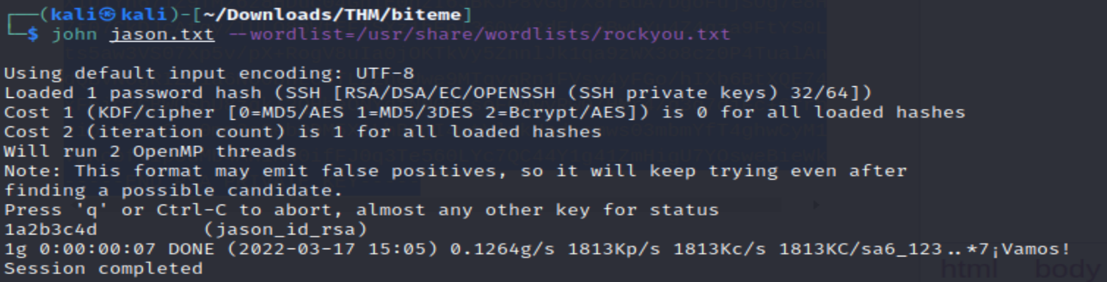

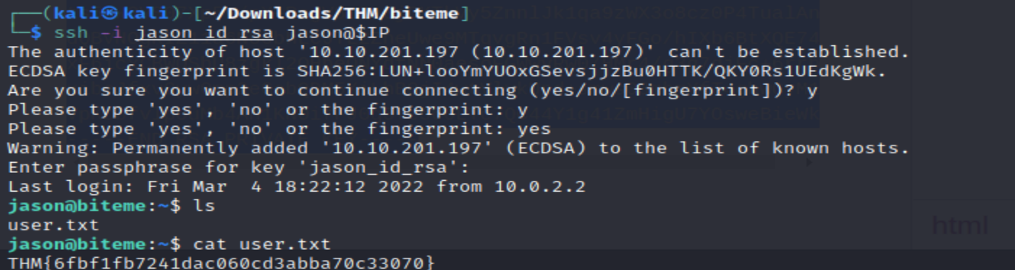

Now to be root , try sudo –l show we have permission changing to user without password , changing to fred show he can actually restart fail2ban as root . fail2bin is IPS , in linux we can use to check port scan ,ssh attack etc



[interesting articles on privesec](https://grumpygeekwrites.wordpress.com/2021/01/29/privilege-escalation-via-fail2ban/) , where they used multiplort iptable

so change the actionban and unban to bash shell chmod

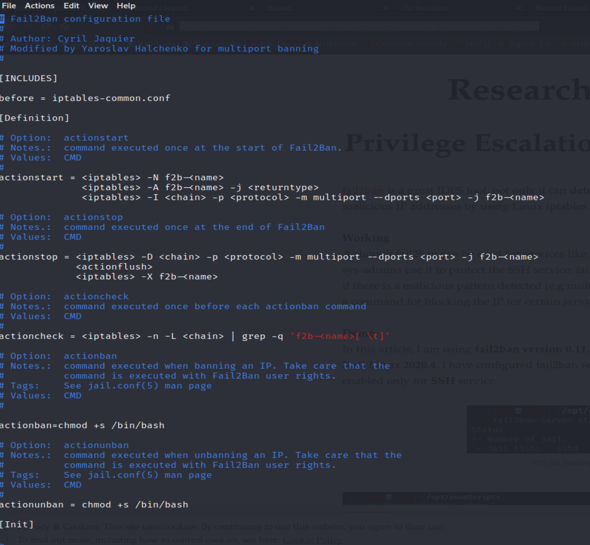

Got suid by spamming

